Student Name :-Shruti Anand Patil

Project Name:- Cake Website

Description

Doceria is a cake website that showcases a variety of delicious and beautifully crafted cakes for all occasions. From birthdays to weddings, Cake Delights offers a range of cakes to suit every celebration. The website features a Products where visitors can view the mouth-watering creations and place orders for their favorite cakes.

Technologies are used:

- HTML: Used for structuring the content of the website.

- CSS: Used for styling and designing the layout of the website.

- JavaScript: Used for adding interactive elements and functionality to the website.

Advantages of this website:

1. Convenience: One major advantage is the convenience it offers to customers. They can browse through a wide variety of cake designs from the comfort of their homes, place orders online, and have the cakes delivered to their doorstep.

2. Time-saving: By ordering cakes online, customers save time that would otherwise be spent visiting a physical bakery. They can quickly place orders at any time of the day.

3. Accessibility: The website can reach a broader audience beyond local customers. People from different locations can access the website, view the cake options, and place orders, expanding the customer base.

4. Client Reviews: Customers can leave feedback and reviews on the website, helping others make informed decisions about their cake choices. Positive reviews can build trust and attract more customers

HOME PAGE

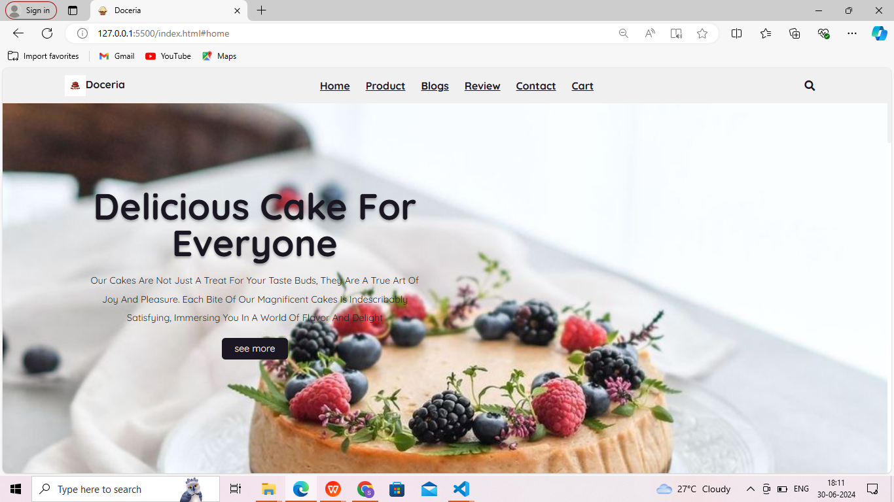

PRODUCT PAGE

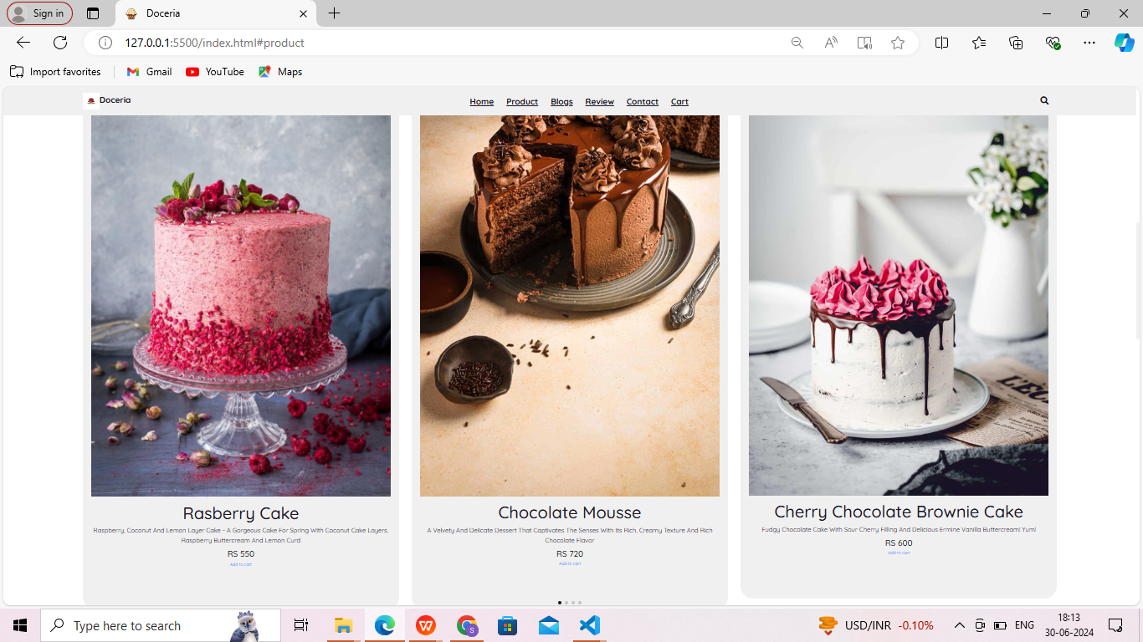

BLOGS PAGE

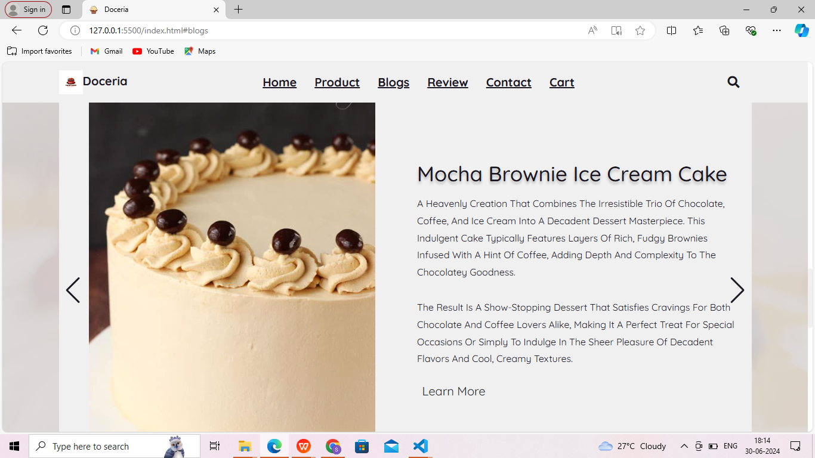

REVIEW PAGE

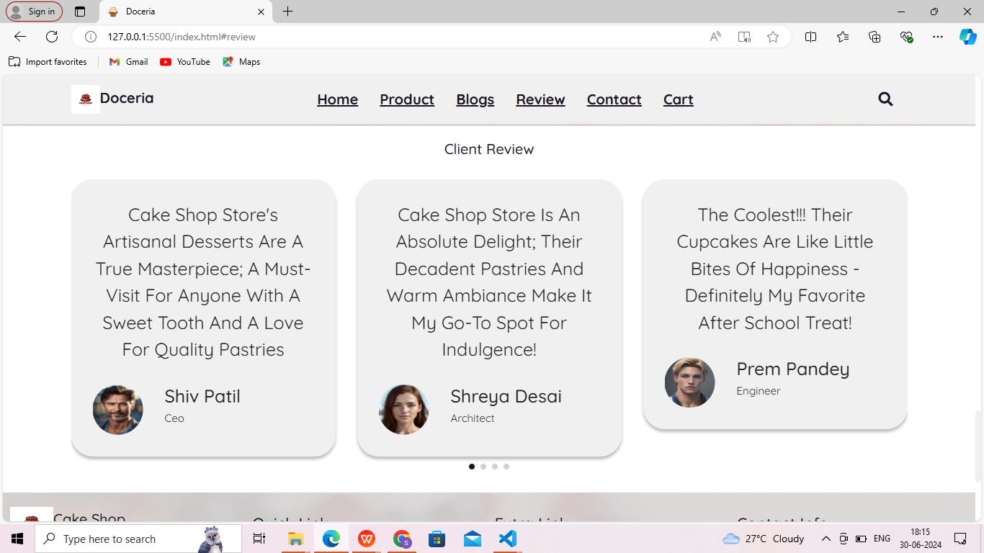

CONTACT PAGE

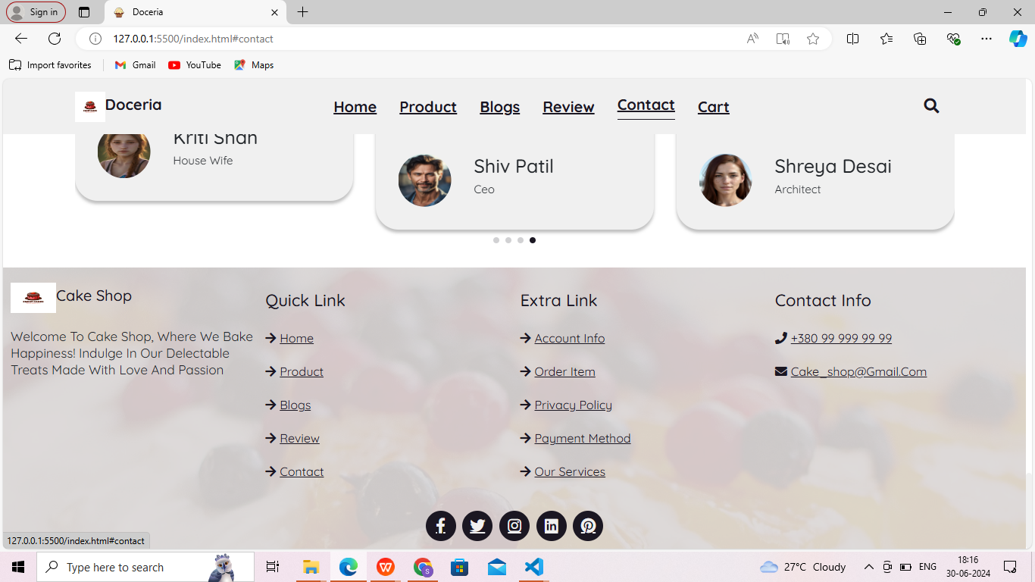

CART PAGE

